WATER QUALITY CLASSIFICATION USING MACHINE LEARNING
A Minor Project Report
Name : Ananya S S
USN : U01BD24S0009
Course : Bachelor’s Of Computer Application(BCA)
College : Jss College For Women, Saraswathipuram, Mysuru-570009
Academic Year : 2026-27

ABSTRACT
Water quality plays a crucial role in protecting public health and ensuring access to safe drinking water. However, traditional water quality assessment methods can be time-consuming and require the analysis of multiple water parameters. This project presents a machine learning-based approach for classifying water samples as potable or non-potable based on their chemical and physical characteristics.
The project uses a water quality dataset containing parameters such as pH, hardness, solids, chloramines, sulfate, conductivity, organic carbon, trihalomethanes, and turbidity. The dataset was preprocessed and analyzed using data cleaning and exploratory data analysis techniques to understand the characteristics and relationships within the data. A Random Forest Classifier was then trained to classify water samples based on their potability.
The model was evaluated using accuracy, classification report, and confusion matrix. The developed model achieved an accuracy of approximately 67.84% on the test dataset. The results demonstrate the potential of machine learning techniques in supporting automated water quality classification and providing a data-driven approach to preliminary water quality assessment.
Keywords: Water Quality, Machine Learning, Classification, Random Forest, Potability, Data Analysis.

INTRODUCTION
Water is one of the most essential resources for the survival and well-being of living organisms. The quality of water directly affects human health, environmental sustainability, and the overall quality of life. Contaminated or unsafe water may contain harmful physical and chemical properties that can make it unsuitable for drinking and other domestic purposes. Therefore, accurate and efficient assessment of water quality is essential for identifying whether a water sample is safe for consumption.
Traditional methods of water quality assessment generally involve laboratory testing and the analysis of multiple parameters. Although these methods can provide reliable results, they may require considerable time, resources, and manual effort. With the growth of data science and machine learning, it is possible to analyze water quality parameters and develop intelligent systems that can assist in classifying water samples automatically.
This project, titled “Water Quality Classification Using Machine Learning,” focuses on classifying water samples into two categories: potable and non-potable. The project uses various water quality parameters such as pH, hardness, solids, chloramines, sulfate, conductivity, organic carbon, trihalomethanes, and turbidity. A machine learning classification model is trained using these parameters to predict the potability of water samples.
In this project, the dataset is first prepared and analyzed using data preprocessing and exploratory data analysis techniques. A Random Forest Classifier is then used to train the model and predict the potability of water. The performance of the model is evaluated using accuracy, classification report, and confusion matrix. This project demonstrates the application of machine learning in supporting data-driven water quality classification.

PROBLEM STATEMENT
Water is one of the most essential resources for the survival and well-being of living organisms. The quality of water directly affects human health, environmental sustainability, and the overall quality of life. Contaminated or unsafe water may contain harmful physical and chemical properties that can make it unsuitable for drinking and other domestic purposes. Therefore, accurate and efficient assessment of water quality is essential for identifying whether a water sample is safe for consumption.
Traditional methods of water quality assessment generally involve laboratory testing and the analysis of multiple parameters. Although these methods can provide reliable results, they may require considerable time, resources, and manual effort. With the growth of data science and machine learning, it is possible to analyze water quality parameters and develop intelligent systems that can assist in classifying water samples automatically.
This project, titled “Water Quality Classification Using Machine Learning,” focuses on classifying water samples into two categories: potable and non-potable. The project uses various water quality parameters such as pH, hardness, solids, chloramines, sulfate, conductivity, organic carbon, trihalomethanes, and turbidity. A machine learning classification model is trained using these parameters to predict the potability of water samples.
In this project, the dataset is first prepared and analyzed using data preprocessing and exploratory data analysis techniques. A Random Forest Classifier is then used to train the model and predict the potability of water. The performance of the model is evaluated using accuracy, classification report, and confusion matrix. This project demonstrates the application of machine learning in supporting data-driven water quality classification.

OBJECTIVES
The main objectives of this project are:
1.To analyze various water quality parameters such as pH, hardness, solids, chloramines, sulfate, conductivity, organic carbon, trihalomethanes, and turbidity.
2.To preprocess and clean the water quality dataset by handling missing values, checking duplicate records, and preparing the data for machine learning.
3.To perform exploratory data analysis (EDA) to understand the distribution of water quality parameters and identify relationships between the features.
4.To develop a machine learning-based classification model for classifying water samples as potable or non-potable.
5.To train a Random Forest Classifier using the available water quality parameters.
6.To evaluate the performance of the classification model using accuracy, classification report, and confusion matrix.
7.To demonstrate the application of machine learning in supporting automated and data-driven water quality assessment.

DATASET DESCRIPTION
The dataset used in this project is a water quality dataset containing different physical and chemical parameters of water. These parameters are used to determine whether a water sample is suitable for drinking. The dataset contains 9 input features and 1 target variable, named Potability.
The input features represent different characteristics of water, while the Potability column represents the classification result. A value of 0 indicates that the water is not potable, while a value of 1 indicates that the water is potable.
The dataset contains the following parameters:
Parameter | Description
pH | Measures the acidity or alkalinity of water.
Hardness | Represents the mineral content of water.
Solids | Measures the total dissolved solids.
Chloramines | Indicates the concentration of chloramines.
Sulfate | Represents the sulfate concentration.
Conductivity | Measures the ability of water to conduct electricity.
Organic Carbon | Represents the amount of organic carbon.
Trihalomethanes | Indicates the concentration of trihalomethanes.
Turbidity | Measures the cloudiness of water.
Potability | Target variable:0=Not Potable,1=Potable.
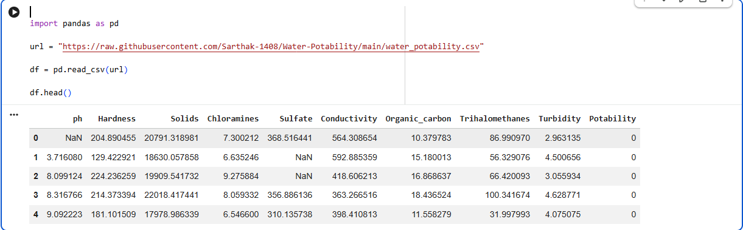
Figure 1:Sample Preview of the Water Quality Dataset.

TOOLS AND TECHNOLOGIES
The following tools and technologies were used for the development of this project:
Programming Language
Python: Used for data preprocessing, analysis, visualization, machine learning model development, and evaluation.
Development Environment
Google Colab: A cloud-based environment used to write and execute Python code and perform machine learning experiments.
Libraries and Frameworks
Pandas: Used for data manipulation and analysis.
NumPy: Used for numerical operations and data processing.
Matplotlib: Used for creating data visualizations and graphs.
Seaborn: Used for statistical data visualization, including the correlation heatmap.
Scikit-learn: Used for data splitting, Random Forest classification, prediction, and model evaluation.
Dataset
Water Quality Dataset: Used to train and evaluate the machine learning classification model.

METHODOLOGY
The methodology followed in this project consists of a series of steps, beginning with data preparation and ending with the evaluation of the machine learning classification model. The overall workflow of the project is as follows:
6.1 Data Preparation
The water quality dataset was loaded and examined to understand its structure and features. The dataset was checked for missing values and duplicate records. Missing values were handled during the data cleaning process, and duplicate records were checked to ensure the quality and reliability of the dataset.
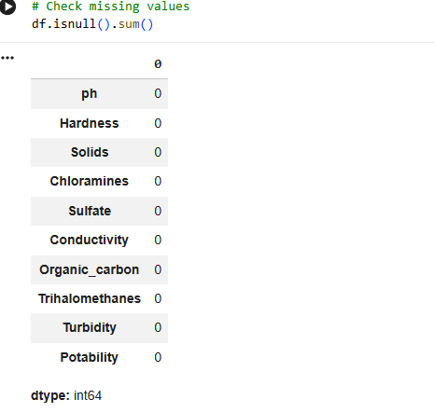
Figure 2:Missing Values Check
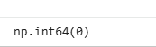
Figure 3:Duplicate Records Check.
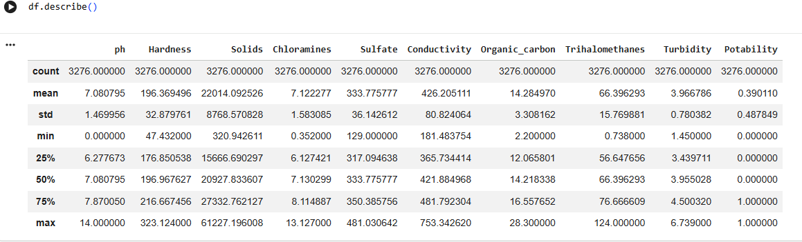
Figure 4:Statistical Summary of the Dataset.

6.2 Exploratory Data Analysis
Exploratory Data Analysis (EDA) was performed to understand the characteristics and patterns present in the dataset. Count plots, histograms, and a correlation heatmap were used to visualize the distribution of the data and examine relationships between water quality parameters and the target variable, Potability.
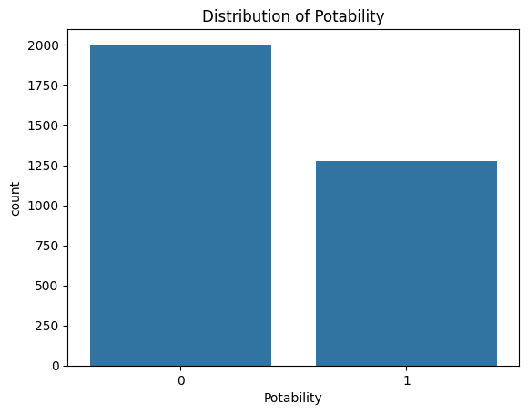
Figure 5:Distribution of Water Potability.

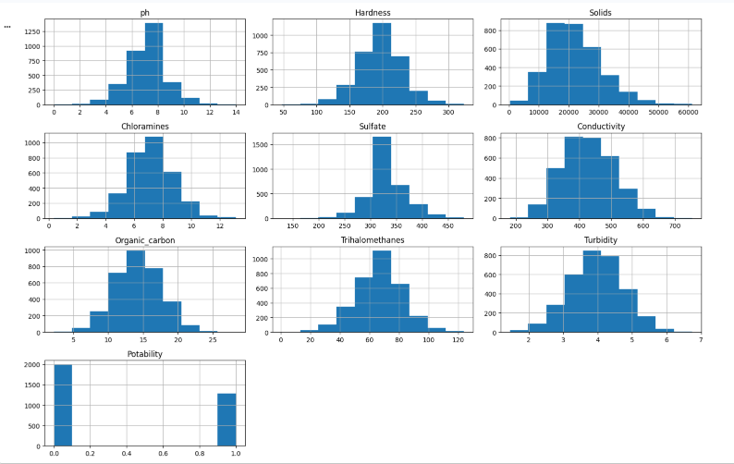
Figure 6:Feature Distribution Graphs.
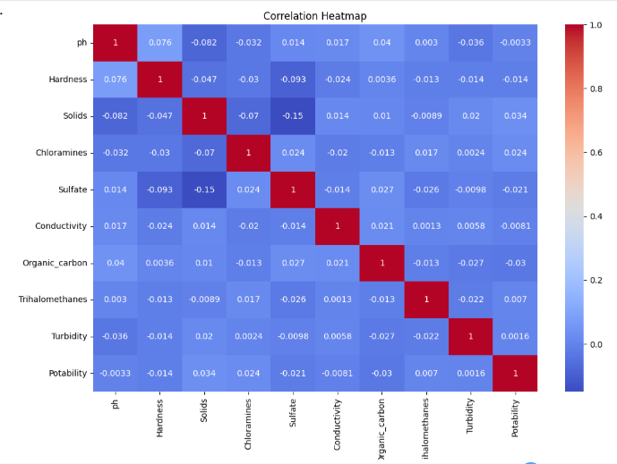
Figure 7:Correlation Heatmap.
6.3 Feature and Target Separation

The dataset was divided into input features and a target variable. The nine water quality parameters were used as input features, while Potability was selected as the target variable. A value of 0 represents non-potable water, and a value of 1 represents potable water.
6.4 Train-Test Split
The dataset was divided into training and testing subsets. 80% of the data was used for training the model, while 20% was used for testing its performance.
6.5 Classification Model
A Random Forest Classifier was used as the machine learning model. Random Forest is a supervised machine learning classification algorithm that combines multiple decision trees to make predictions. The model was trained using the water quality features and their corresponding potability labels.

6.6 Prediction and Evaluation
After training, the model was used to predict the potability of the test samples. The performance of the model was evaluated using accuracy, classification report, and confusion matrix.

SYSTEM IMPLEMENTATION
The Water Quality Classification system was implemented using Python in the Google Colab environment. The implementation consists of several stages, including dataset loading, data preprocessing, exploratory data analysis, model training, prediction, and performance evaluation.
7.1 Dataset Loading
The dataset was loaded into the Python environment using the Pandas library. The data was stored in a DataFrame, which allowed efficient analysis and manipulation of the dataset.
import pandas as pd
df = pd.read_csv('water_potability.csv')
7.2 Data Preprocessing
The dataset was checked for missing values and duplicate records. Missing values were handled, and the dataset was checked for duplicate rows to improve the quality of the data used for model training.
7.3 Exploratory Data Analysis
The dataset was analyzed using graphs and visualizations. A count plot was used to examine the distribution of potable and non-potable water samples. Histograms were used to visualize the distribution of the water quality features. A correlation heatmap was also created to analyze the relationships between the features and the target variable.
7.4 Feature and Target Separation
The dataset was divided into input features and a target variable. The water quality parameters were used as input features, while the Potability column was selected as the target variable.
X = df.drop('Potability', axis=1)
y = df['Potability']
7.5 Train-Test Split
The dataset was divided into training and testing data using the train-test split method. Eighty percent of the data was used for training the model, while the remaining twenty percent was used for testing the model.
X_train, X_test, y_train, y_test = train_test_split(X, y, test_size=0.2, random_state=42)
7.6 Model Training
A Random Forest Classifier was selected for the classification task. The model was trained using the training dataset to learn the relationship between the water quality parameters and the potability of water.
model = RandomForestClassifier(random_state=42)
model.fit(X_train, y_train)
7.7 MODEL PREDICTION
After training the Random Forest Classifier, the trained model was used to predict the potability of the water samples in the test dataset. The model generated predictions based on the water quality parameters provided as input
y_pred = model.predict(X_test)
7.8 MODEL EVALUATION
The performance of the trained classification model was evaluated using the accuracy score. Accuracy measures the percentage of correctly classified samples out of the total test samples.
from sklearn.metrics import accuracy_score
accuracy = accuracy_score(y_test, y_pred)
print("Accuracy:", accuracy)
The Random Forest Classifier achieved an accuracy of approximately 67.84% on the test dataset.
7.9 CLASSIFICATION REPORT
A classification report was generated to evaluate the model using precision, recall, and F1-score for the two classes, namely potable and non-potable water.
from sklearn.metrics import classification_report
print(classification_report(y_test, y_pred))

7.10 CONFUSION MATRIX
A confusion matrix was used to compare the actual water potability values with the values predicted by the model. It provides a detailed representation of the correct and incorrect classifications made by the Random Forest Classifier.
from sklearn.metrics import confusion_matrix
cm = confusion_matrix(y_test, y_pred)
sns.heatmap(cm, annot=True, fmt='d', cmap='Blues')
plt.xlabel('Predicted')
plt.ylabel('Actual')
plt.title('Confusion Matrix')
plt.show()

RESULTS AND DISCUSSION
The developed Water Quality Classification model was evaluated using the test dataset to determine its performance in classifying water samples as potable or non-potable. The performance of the Random Forest Classifier was analyzed using accuracy, classification report, and confusion matrix.
8.1 Accuracy
The Random Forest Classifier achieved an accuracy of approximately 67.84% on the test dataset. This indicates that the model correctly classified approximately 68 out of every 100 water samples in the testing data.
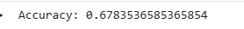
Figure 8:Model Accuracy.

8.2 Classification Result
The classification report provides detailed performance measures such as precision, recall, and F1-score for both potable and non-potable water classes. These metrics help in understanding the performance of the model beyond the accuracy score.
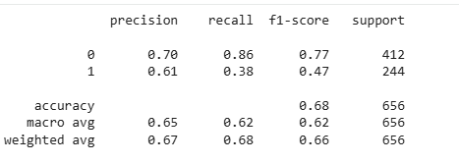
Figure 9:Classification Report.
8.3 Confusion Matrix Analysis
The confusion matrix provides a detailed comparison between the actual and predicted classes. It shows the number of correctly and incorrectly classified samples for both potable and non-potable water. This helps in identifying the classification errors made by the model.
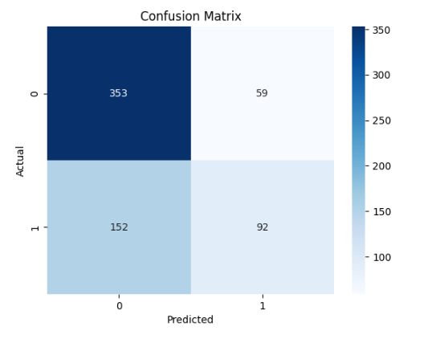
Figure 10:Confusion Matrix.

CONCLUSION
This project presented a machine learning-based approach for classifying water samples as potable or non-potable based on various water quality parameters. The dataset was prepared and analyzed through data preprocessing and exploratory data analysis techniques. The input features were separated from the target variable, and the dataset was divided into training and testing sets.
A Random Forest Classifier was trained using the water quality parameters and used to predict the potability of water samples. The model achieved an accuracy of approximately 67.84% on the test dataset. The performance of the model was further analyzed using a classification report and confusion matrix.
The project demonstrates the application of machine learning in water quality classification and shows how data-driven techniques can be used to support the preliminary assessment of water potability. Although the model provides useful classification results, further improvements can be explored to enhance its performance and reliability.

FUTURE SCOPE
The Water Quality Classification project can be further enhanced in several ways. Future work can focus on improving the accuracy and reliability of the classification model by applying advanced machine learning and ensemble techniques. Different algorithms can also be compared to identify the most suitable model for water quality classification.
The project can be extended by using larger and more diverse water quality datasets collected from different geographical locations. Additional water quality parameters can also be included to improve the overall analysis and prediction capability of the system.
In the future, the trained model can be integrated into a web or mobile application, allowing users to enter water quality parameters and receive an immediate prediction regarding the potability of the water. The system can also be enhanced to support real-time monitoring through IoT-based water quality sensors.
These improvements can help develop a more efficient, intelligent, and practical water quality assessment system.

REFERENCES
1.Python Software Foundation, Python Documentation. Available at: https://docs.python.org/3/⁠�
2.The pandas development team, pandas Documentation. Available at: https://pandas.pydata.org/docs/⁠�
3.Scikit-learn Developers, Scikit-learn: Machine Learning in Python. Available at: https://scikit-learn.org/stable/⁠�
4.Matplotlib Development Team, Matplotlib Documentation. Available at: https://matplotlib.org/stable/⁠�
5.Waskom, M., seaborn: Statistical Data Visualization. Available at: https://seaborn.pydata.org/⁠�
6.Google, Google Colaboratory Documentation. Available at: https://colab.research.google.com/⁠�
7.Sarthak-1408, Water-Potability: Water Potability Dataset, GitHub Repository. Available at: https://github.com/Sarthak-1408/Water-Potability⁠�

